SISTER NIVEDITA MONTESSORY SCHOOL
ENGLISH
CLASS – L.K.G
CAPITAL\SMALL “C”
PRACTICE 3 PAGES
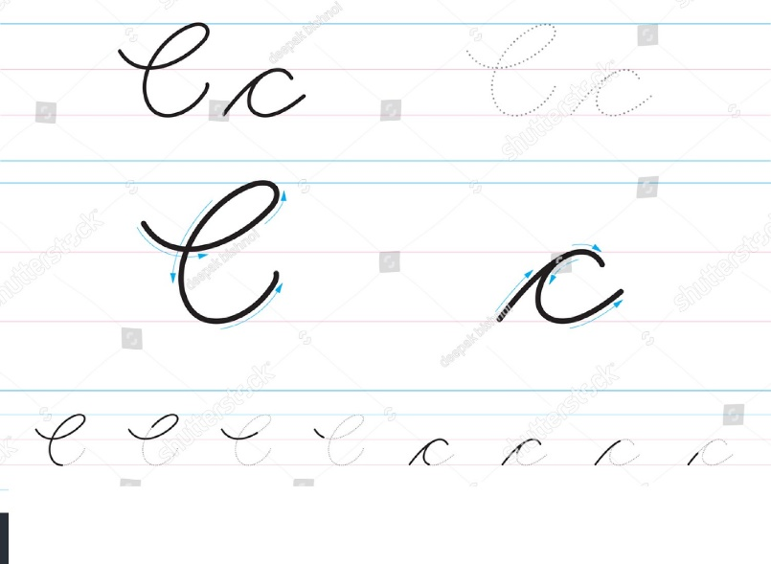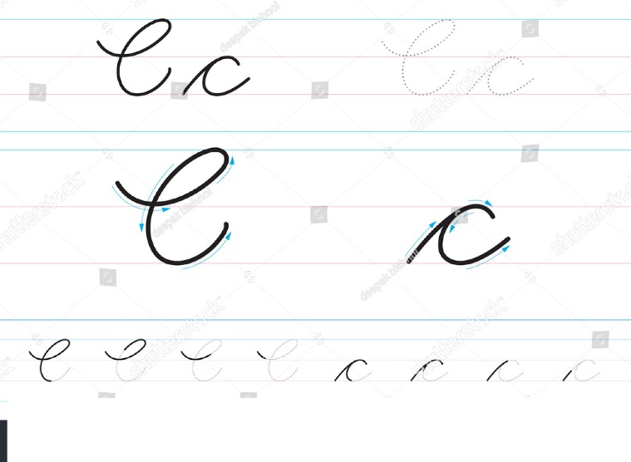
PRACTICE A/a & B/b.
